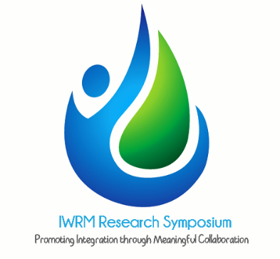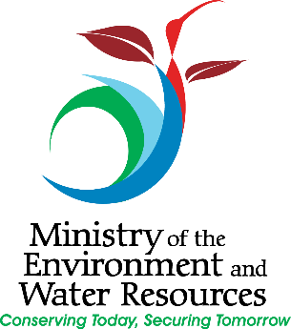**IWRM Research Symposium 2015**

**Water and Sustainable Development**

***“Promoting Integration through meaningful collaboration****”*

***15th – 16th July, 2015***

***UWI Conference Centre, St Augustine***

**Call for Papers**

**Background**

Water, in particular freshwater is central to all developmental efforts. However, this resource is facing rising pressures due to over consumption, underinvestment, lack of human capacity, poor management of waste and increasing demands from agriculture, energy and food production. These challenges are due primarily to a growing population that fails to use freshwater in a sustainable manner. Since most problems are socio-economic and political in nature they can be addressed through intelligent and effective governance. This approach will facilitate the optimization of water use between sectors and the natural environment without compromising future needs. There is an urgent need for government, private sector and civil society to work more closely together and to integrate water as an intrinsic part of national development.

This symposium seeks to highlight the projects and experiences of practitioners in the water sector that promote sustainable development. It will provide a space for dialogue on selected topics relevant to the implementation of Integrated Water Resources Management (IWRM). The symposium will focus on transformations necessary to improve the management of our water resources through institutional change, technology, capacity development and financial arrangements.

**Registration**

We encourage you to register your interest in participating the IWRM Research Symposium. Please click [here](https://docs.google.com/forms/d/1CjhhiH_VTqR6mclMPhpPIxB4xIznw8Qk72t9K9rYqqE/viewform?usp=send_form) to register your attendance.

**Submission**

All authors interested in submitting abstracts for consideration, must do so electronically to the following email address ([iwrmsymposium2015@gmail.com](mailto:iwrmsymposium2015@gmail.com)). Abstracts should be entitled: ***IWRM Research Symposium on Water for Sustainable Development 2015 on: (sub-theme).*** An alternative to email is the use of the [Online Abstract Submittal Form](https://docs.google.com/forms/d/1CjhhiH_VTqR6mclMPhpPIxB4xIznw8Qk72t9K9rYqqE/viewform?usp=send_form).

**Dates to remember**

Deadline for **ALL** abstracts is **April 30, 2015**.

Notification of successful abstracts/authors will be given by **May 15, 2015**.

Full papers should be submitted no later than **June 12, 2015**.

All papers will be published in the official conference proceedings.

**Topics**

# Hydrology and Meteorology

* Impact issues affecting quantity and quality of water resources
* Relationship between rainfall, streamflow and urbanization
* Flood modeling and forecasting
* Groundwater resources
* Groundwater – surface water interactions and conjunctive use of water resources
* Influence of meteorological parameters in IWRM

# Water and the Environment

* Environmental Impact of water resources
* Ecosystem needs, preservation of aquatic biodiversity and environmental flows
* Integrated coastal zone management
* Land, biodiversity and water resource management
* Solid and liquid waste management
* Integrated river basin management
* Wetland conservation and management

# Water and Land

* Irrigation management/crop water requirement/deficit irrigation
* Soil and water conservation techniques
* Agrochemical use and its impact on water resources
* Drought management options
* Impact of quarrying/mining activities on water resources
* Land use Planning and its impact on Water Resources
* Impact of changing climate on water

# Water Quality, Health and Supply

* Role of water quality in IWRM
* Water pollution and river health
* Marine pollution
* Emerging contaminants
* Remediation and modelling
* Water quality impact on human health
* Groundwater quality/contamination
* Water quality impact on water supply
* Sustainable sanitation and water supply
* Recharge, recycle and reuse of water
* Water supply in times of disasters

# Water, Society and Governance

* Economic instruments for water management
* Public-private partnership in water resources management
* Institutional framework for IWRM
* Socio-economic and livelihood factors on water resources
* Participatory approach in water resources management
* Water policy, legislation, implementation and enforcement

**Layout and format for abstracts and papers**

Authors are kindly requested to adhere to the following rules:

Abstract format for papers and posters:

* Length: Abstracts should not be more than half page or 300 words
* Page size: Letter size (8.5” x 11”)
* Margins: double spaced with minimum margins of 2.5cm all round
* Word-processed work should be justified
* Font: Arial in size 11.
* Digital Format: Microsoft Word of PDF Format
* Key words (3-7);
* A note about the author of max. 80 words;
* A statement about the originality, of the idea and how it will illustrate the hemispheric trend on the theme.
* Topic: Place general topic above the title of the paper with the formatting as it would appear in the final publication

For paper

* Length: Papers should be no more than 10 pages
* Page size: Letter size (8.5” x 11”)
* Margins: double spaced with minimum margins of 2.5cm all round
* Word-processed work should be justified
* Font: Arial in size 11.
* Digital Format: Microsoft Word of PDF Format
* Key words (3-7);
* A note about the author of max. 80 words;
* A statement about the originality, of the idea and how it will illustrate the hemispheric trend on the theme.
* Topic: Place general topic above the title of the paper with the formatting as it would appear in the final publication

Moreover each paper should have:

1. Key words (3-7);
2. Abstract of max. 80 words;
3. A summary of max. 250 words;
4. A note about the author of max. 80 words;
5. Each paper must be accompanied by the names and affiliation of all authors
6. Include contact addresses (including email) and phone contact information
7. A statement about the originality, authorship of the paper indicating that it was not published earlier.

For Poster

* Poster size: 36’ x 48’
* You will be required to print your own poster
* The Title should be formatted to sentence case, not CAPS or Title case and title should not cross over two lines

Receipt of proposals submitted will be acknowledged via email. If a reply is not received within a week then the proposal was not received. We suggest, then, to contact the Symposium Secretariat at 662-2302 ext 6514 or via email at [iwrmsymposium2015@gmail.com](mailto:iwrmsymposium2015@gmail.com).